***STP: “Merkaza” project***

**Table of contents**

**1. INTRODUCTION 3**

**2. SCOPE 3**

2.1. Test items 3

2.2. Features to be tested 3

2.3. Features not to be tested 3

**3. SCOPE OF TESTING 4**

3.1. Test levels 4

3.2. Test types 4

3.3. Test types not to be tested 4

**4. APPROACH 4**

4.1. Schedule 4

4.2. Deliverables 5

4.3. Defects 5

4.4. Entry/Exit Criteria 6

4.5. Roles and Responsibilities 7

4.6. Resources and Environments 7

# INTRODUCTION

The website is an online trade website which is designed to provide information about the services offered by Merkaza and provides users of the website with the opportunity to purchase a wide variety of services, to place orders for a wide variety of products, including household products and textile products, pharmaceutical and cosmetic products, kitchen products, cooking and baking, Gardening, camping and leisure products and more. Among other things, after registering for the site's services through an online form, you can edit shopping lists, purchase products or order various services, track the status of the order online, make purchases by reviewing the user's previous shopping history, create a preferred shopping list, permanent shopping baskets and more A wide range of options to customize the purchase process. In addition, you can keep up to date with promotions and new products, tips, recipes and useful and efficient information in all areas of the website.

# SCOPE

## 2.1. Test items

1. Purchase products
2. checkout process
3. track the status of the order online
4. Search functionality
5. Registration and login
6. Logout
7. Account settings
8. “הרשימות שלי”
9. shopping cart
10. Payment with coupons
11. Choosing delivery times
12. Product return and exchange service
13. Product catalog
14. Contact page
15. Support service with a chat representative
16. Newsletter
17. Bottom menu
18. Cancel orders
19. Categories menu
20. Merkaza careers
21. “Merkaza online”

## 2.2. Features to be tested

1. Search functionality
2. Registration and login
3. Logout
4. “הרשימות שלי”
5. shopping cart
6. Product catalog
7. “Merkaza online”
8. Support service with a chat representative
9. Newsletter
10. Bottom menu
11. Account settings
12. Categories menu.
13. Accessibility button
14. Merkaza careers

## 2.3. Features not to be tested

1. Purchase product
2. checkout process
3. track the status of the order online
4. Payment with coupons
5. Choosing delivery times
6. Product return/exchange service
7. Cancel orders

.

# SCOPE OF TESTING

## 3.1. Test levels

* smoke test
* sanity test
* regression test

## 3.2. Test types

* Functional testing
* Gui testing
* Boundary testing
* Accessibility testing
* Compatibility testing
* Error handling testing
* Usability testing
* Stress testing
* Performance testing
* Negative testing
* Recovery testing

## 3.3. Test types not to be tested

* Security testing

# APPROACH

## 4.1. Schedule

| **Task** | **Effort (Days)** | **End Date** |
| --- | --- | --- |
| Software Test Plan | 2 | 09/03/24 |
| System Test Scripts | 29 | 07/04/24 |
| System Testing | 3 | 10/04/24 |
| software test report | 1 | 10/04/24 |
| Demo | 1 | 14/04/24 |

## 4.2. Deliverables

| **deliverable** | **responsibility** |
| --- | --- |
| STP- Software test plan | Defines your testing team's test strategy, goals, and scope, which ultimately work together to ensure that all your software components are tested sufficiently before a release |
| STD-Software test design | document that specifies how the tests will be performed through a precise description of the test scenarios. |
| STR-Software test report | document that contains a summary of all test activities and final test results of the testing project |
| BUG REPORT | document that describes the defects in the website, including their severity and steps to replicate the problem. |
| DEMO | Presenting the project and its products to the class |

### 4.3. Defects

| **Severity** | **Description** |
| --- | --- |
| 1 – Showstopper | critical defect that stops the website or operating system in its tracks |
| 2 – High | High defects (and crashes) are those which also cause failure of the entire or part of the system |
| 3 - Medium | Medium defects do not result in failure but cause the system to show incorrect, incomplete, or inconsistent results. |
| 4 – Low | Low defects are small errors that do not affect the functionality: typos, grammar mistakes, wrong terminology, etc. |

**The bug report document will be written in Excel**

**Link -** [Bug Reports](https://docs.google.com/spreadsheets/d/16_R0mX7kODu2KdgUURbvAH6jzQ3P8z4xvhckfmfI_RQ/edit?usp=drive_link)

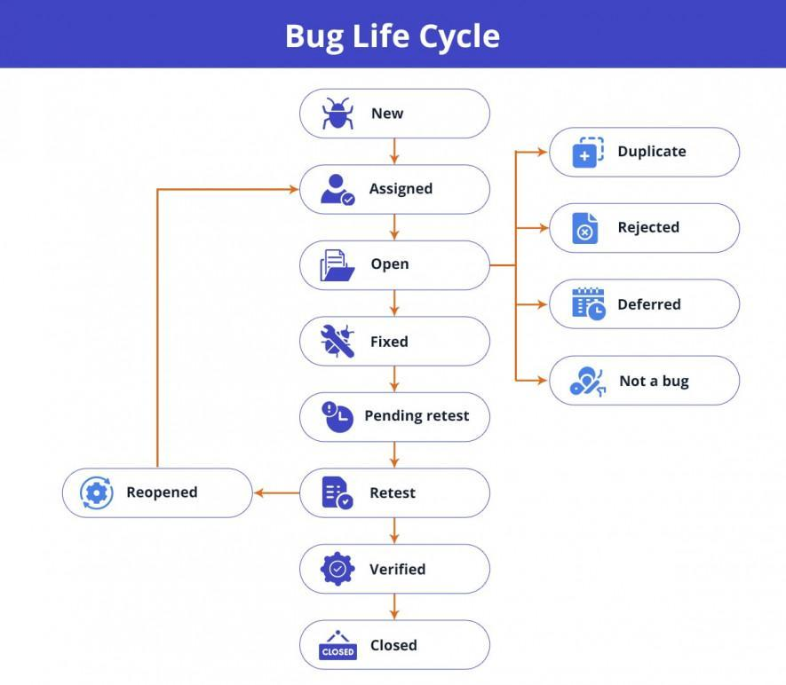

### 

### 4.4. Entry/Exit Criteria

**Entry system testing:**

* A working version of the site.
* Software requirements specification is created.
* Testing Environment is prepared.

**Exit system testing:**

* There are no show-stopping bugs.
* The number of bugs with a high severity level will not be more than 5.
* All tests will be performed a week before the deadline.
* The number of bugs with a medium severity level will not be more than 15.

### 4.5. Roles and Responsibilities

| **Staff Name:** | **Role:** | **Responsibility:** |
| --- | --- | --- |
| Ido Yevdayev | Scrum master | Conducts the daily scrum meetings and responsible to test the following features: Product catalog, Search functionality, Support service with a chat representative, Bottom menu, Merkaza careers |
| Simcha Nakash | senior tester | responsible to test the following features: Shopping cart, Categories menu, Accessibility button, |
| Marlaen Ganem | Junior tester | responsible to test the following features: Account settings, Merkaza online |
| Matan Levi | manual QA | responsible to test the following features: Registration and login, Logout, Newsletter,  “הרשימות שלי” |

### 

### 

### 4.6. Resources and Environments

Testing will be conducted on the following platforms:

* Operating systems: Windows 10, Windows 11.
* Web browsers: Chrome, Mozila Firefox, Internet explorer.
* Devices: Laptops.
* Physical tools: Credit card for payment features.
* software licences: Microsoft office, Google drive.
* Social network accounts : Facebook, Instagram, whatsapp.

Web applications that we are going to use to write all our documents:

* Word
* Exel
* Google docs
* Powerpoint